**Solutions**

**Paper 1**

1. Blue
2. Compass
3. Caring, Learning and achieving together as part of God’s Family
4. Salmon Garden – named after Parish priest Father Salmon
5. Blue
6. Sue, Sorelly and Aya (will accept Fabiola although she left recently)
7. John
8. 3
9. Thomas More
10. 1962

**Paper 2**

1. Bounty
2. Lion Bar
3. Mars
4. Double Decker
5. Kit kat chunky
6. Yorkie
7. Mint Aero
8. Boost
9. Snickers
10. Milky Way
11. Fudge
12. Toffee Crisp
13. Cadbury Caramel
14. Turkish Delight
15. Picnic
16. Crunchie

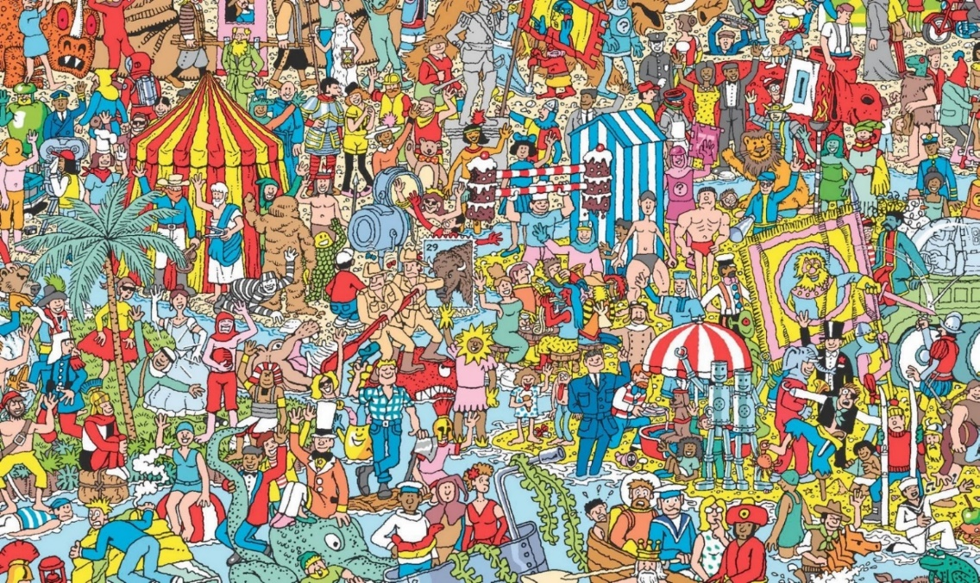**Paper 3**

**Paper 4**

Door – Y6 cloakroom (boys toilet door)

Sinks – Reception

Winnie the Pooh – y6 classroom

Pencil – Music Room

Safe – Office

Cross – hall

Plaque – Playground

Fireplace – Y2

**Paper 5**

Timed task

**Paper 6**

1. There
2. Really
3. Is
4. No
5. Spelling
6. Test
7. Happy
8. Lockdown
9. SATs
10. Endeavour

**Paper 7**

Art task

**Paper 8**

1. You!

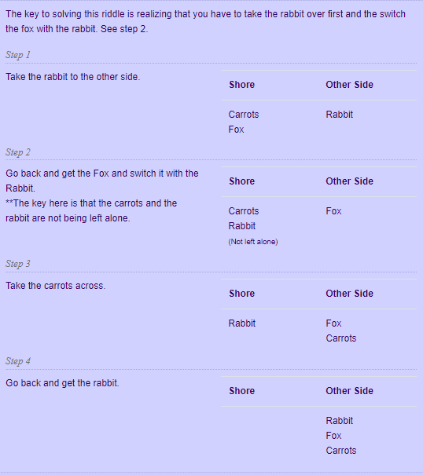

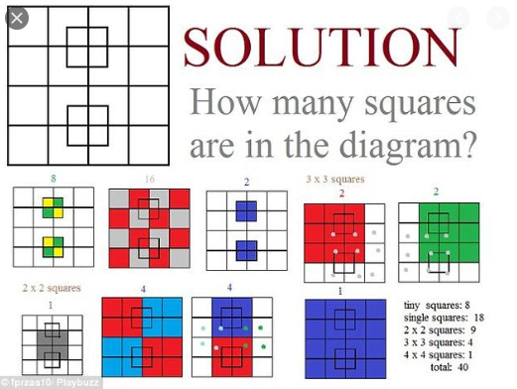



**Paper 9**

1. **Cat in the hat**
2. **The Hungry Caterpillar**
3. **Matilda**
4. **Green Eggs and Ham**
5. **3 Little Pigs**
6. **Alice and Wonderland**
7. **James and the Giant Peach**
8. **Harry Potter**
9. **Charlotte’s Web**
10. **Charlie and the Chocolate Factory**
11. **The Rainbow Fish**
12. **Tiger came to tea**
13. **Black Beauty**
14. **We’re going on a bear hunt**
15. **The lion, the witch and the wardrobe**

**Paper 10**

Secondary schools – different answers

**Paper 11**

Celebration task