Supplementary Parent Guide to Remote Learning for Special Educational Needs Pupils

1. How to support your child to engage in home learning

Reception – Year 2 | Year 3 – Year 6
This is just an example please adjust this to what your school is planning  Early Morning Work on insert your schools chosen learning platform  Phonics-  AM lessons- PDF with audio layered on top via insert your schools chosen learning platform  – there will be a parent guidance slide at beginning of each lesson​  PM lessons- PDF with audio layered on top via insert your schools chosen learning platform - there will be a parent guidance slide at beginning of each lesson​  (Full school timetable in Resource Appendix below)  Please insert any instructions or videos for parents on how to use your schools learning platform | This is just an example please adjust this to what your school is planning  Early Morning Work and register- TEAMS- live- record register by teachers​  Core lessons (Reading, Writing and Maths) - live input from teachers via TEAM  Pupils may be asked to attend an additional small seminar group led by teachers  Assessment will take place via insert your schools chosen learning platform  ​  Wider Curriculum lessons- via insert your schools chosen learning platform  (Full school timetable in Resource Appendix below)  How to access teams for parents: How to access Microsoft Teams  Please insert any instructions or videos on how to use your schools learning platform

2. Importance of establishing routines and expectations

It’s normal for a lack of routine and structure to make children feel anxious and upset, especially if they have special educational needs and disabilities. If your child’s no longer going to school, creating a routine is important and there are ways you can do this together.

It’s important to include your child when thinking about how you structure the day and different activities you can do together. You might want to think about having different routines or activities in different rooms for example, depending on the space you have at home. Perhaps there’s something your child loves doing, like artwork or playing games that can become part of their daily routine.
It can help to ask your child’s school what they normally use to create routines.
Popular examples include:
- a ‘Now and Next’ board, using two pictures to show what’s happening now and what the child will be doing next. (in Resource Appendix)
- a visual timetable, using pictures to plan the day. If the whole day is too much to focus on, a timetable could be made for a morning or an afternoon instead.
- a weekly timetable, to show key things to look forward to on different days.
- Pictures are easier for many children to understand than written words. There is a visual timetable below, or you could draw your own. Some children will want to know the time when different activities will start, but other children won’t need this. It can help to ask your child what they’d prefer.

3. Choose a good place to learn with space
Your family’s regular learning space for occasional homework might not work for extended periods. Set up a physical location that’s dedicated to school-focused activities. Make sure it is quiet, free from distractions and has a good internet connection. Make sure you have enough room for any additional resources you will need to support your child at home.

4. Stay in touch
Teachers will mainly be communicating regularly through our online platforms and virtual learning environments. Make sure everyone knows how to find the help they need to be successful. Stay in contact with classroom and support teachers and school leaders but understand it may take a day or two for us to respond. If you have concerns, let someone know. You can contact the Inclusion Team at insert your email address should require additional support for your child at home.
Your child may be missing their friends and adults they see regularly. Try to think about other ways they can see or speak to them. For example, having phone or video calls or talking to friends online via chat or when playing online games. Having regular times each day to speak to family or friends may help.

There is online safety advice for parents to help you keep your child safe if they’re spending more time online during lockdown. You may find advice on talking to your child about online safety, livestreaming and online video apps and inappropriate content particularly helpful.

4. Try activities together
Your child might be behaving differently because they’re feeling anxious about things changing. Activities can help to give them the space and time to express their feelings.
Children with special educational needs and disabilities benefit from different types of activities. While some young children may benefit most from short activities for just a few minutes, an older child with autism might find activities they can get really absorbed in for a long time more helpful.
But don’t feel pressured to create lots and lots of new activities - repetition is important too. Practical, fun activities which involve different senses can be the most engaging. If possible, you could create a quiet space for activities in your home, even if it’s just the corner of a room, and fill it with homemade toys and games.

Younger children might enjoy:
- using homemade playdough (adding herbs introduces smell too)
- melting chocolate or mixing ingredients
- making marks in materials (e.g. sand, flour, shaving foam or paint)
- listening to music
- making sounds with objects from around the home
- listening to stories (online, over video calls, or with someone at home)
- singing nursery rhymes.
Older children might enjoy:
- zoom chats with group of friends, including zoom apps and games
- turning a well-known story with parents and siblings into a little play, with each adult or child having a short part to make up the whole story. You can adapt this based on your child’s age or ability
- gaming or playing online games with siblings. Games should be age-appropriate
- making a colourful picture using different materials or paints, celebrating NHS and carers
- making a cake or similar and setting a challenge for a friend
- have a ‘blind’ testing competition of food or smells with the family. If your child has a specific diet smells may be more appropriate.

5. Help your child to express their feelings
Lots of us feel isolated at the moment, but this can be even more difficult for children with communication needs.

You might choose to use social stories to talk about coronavirus (COVID 19). Your child could then use emotion pictures to identify and express how they’re feeling.
Families who use Makaton can also find support from the Makaton charity. And there are signed stories you can watch on the Singing Hands website.

Uncertainty can be a particular challenge for some children with special educational needs and disabilities, and they’re likely to find this especially difficult at the moment. Advice for parents can be found on talking to children about coronavirus to help you support a child struggling with anxiety.

Childline also has support and advice for children and young people on managing anxiety and on coronavirus.

Support if you are struggling

Being a parent or carer of a child with special educational needs and disabilities can be challenging and isolating at the best of times. But at the moment, it might be even more difficult. Online communities such as the National Autistic Society’s online community can be a great way to connect with other parents and carers while staying at home.

You might also want to think about how you could create some regular breaks for everyone at home. Perhaps there’s a quiet room where you can relax, or a time of day when one person can sit inside while others are outside or in the garden.
Worrying about your child’s care is natural. If things are tough, don’t struggle alone. If you’d like to talk to someone for advice, there are lots of charities who specialise in different areas of special educational needs, many of which have their own helplines. These include the Council for Disabled Children and the National Network of Parent Carer Forums. Carers UK also offers guidance around care and coronavirus.
You can also phone the NSPCC helpline on 0808 800 5000 or email help@nspcc.org.uk for support.

Resources Appendix

Please find resources to support SEND pupils with remote learning at home below.
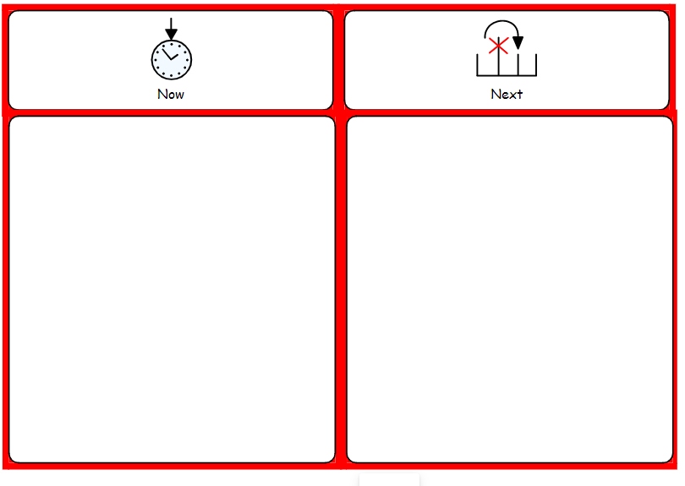
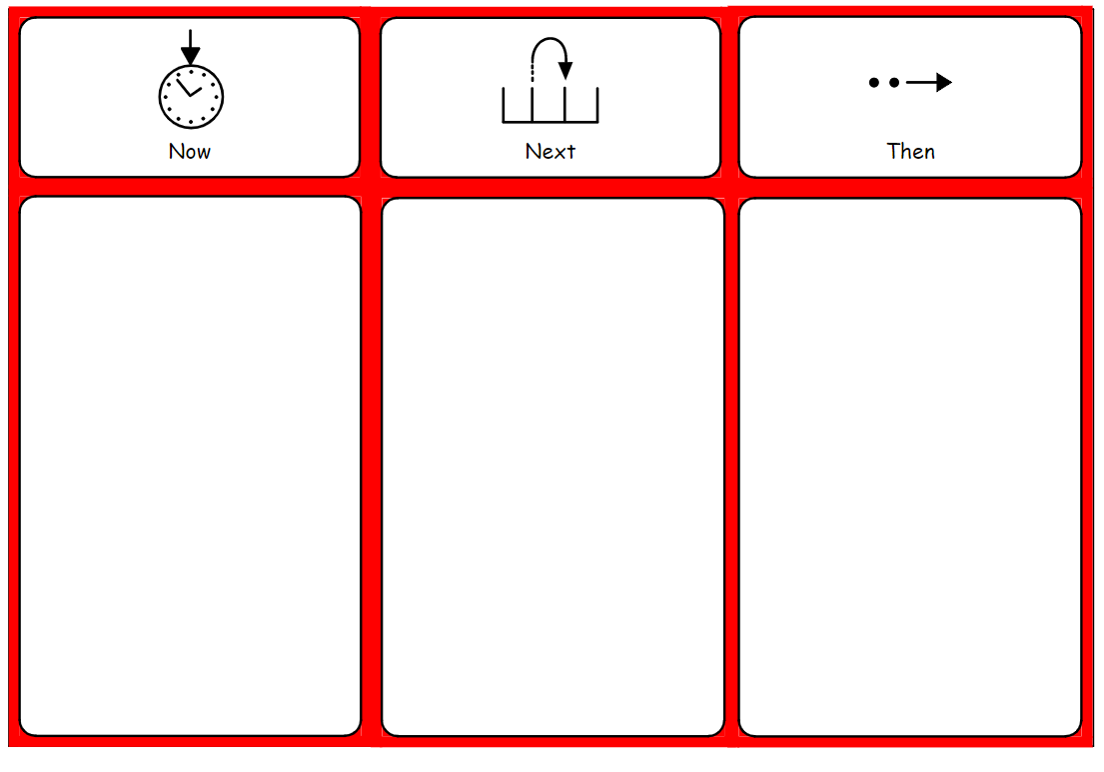

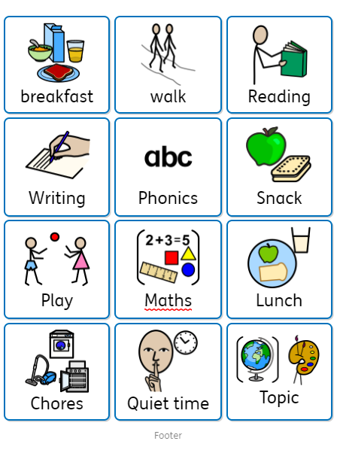
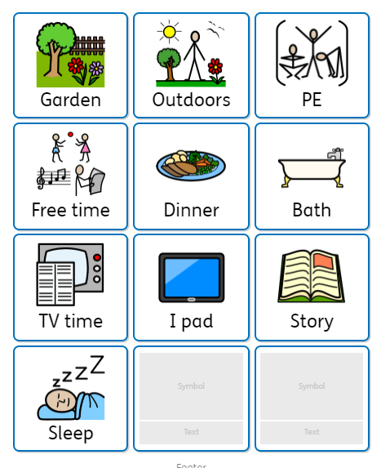

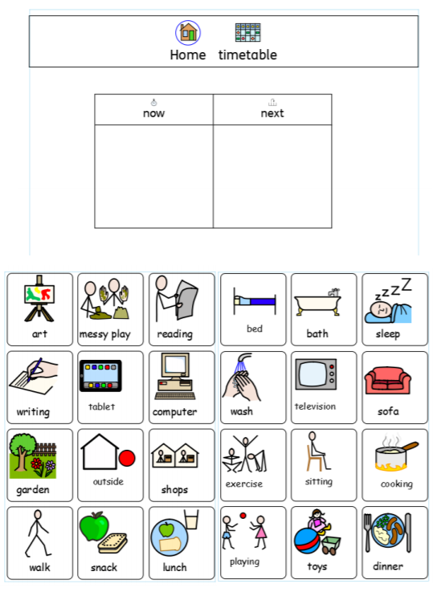
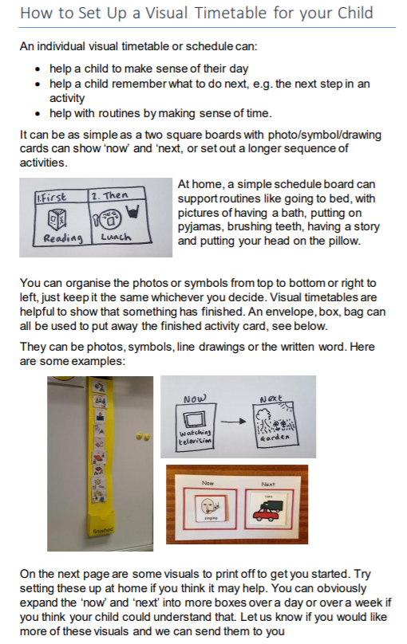

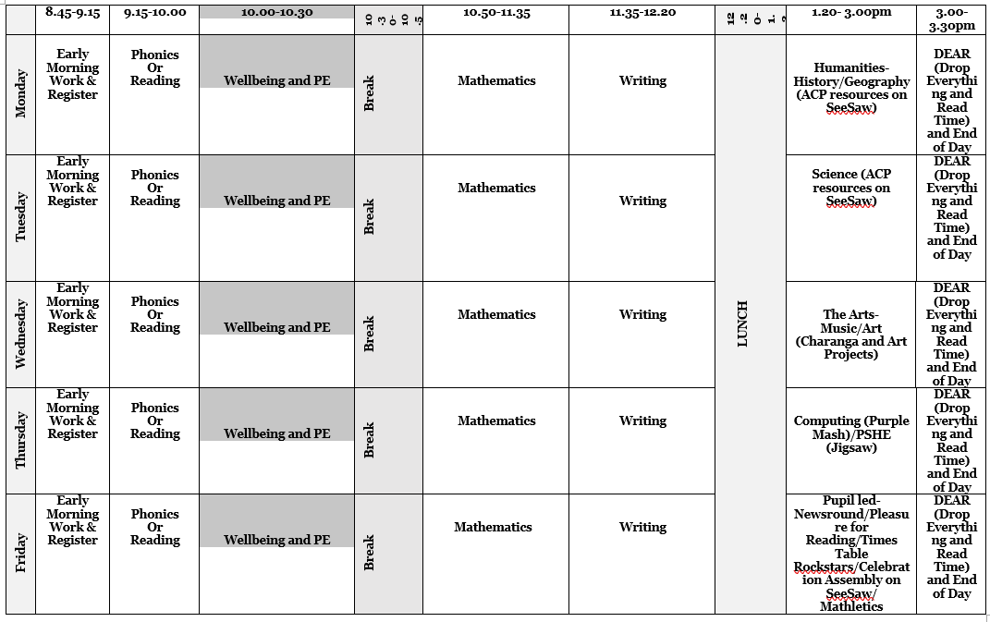

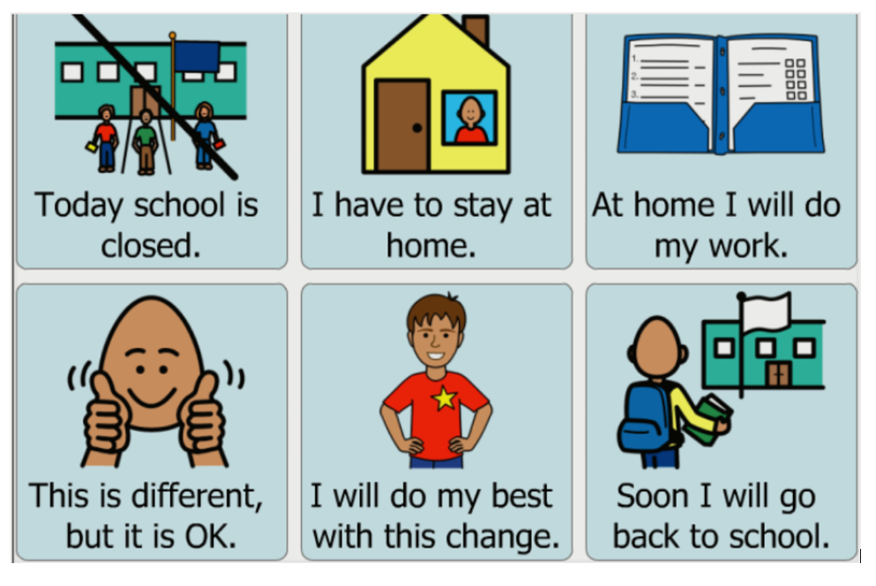
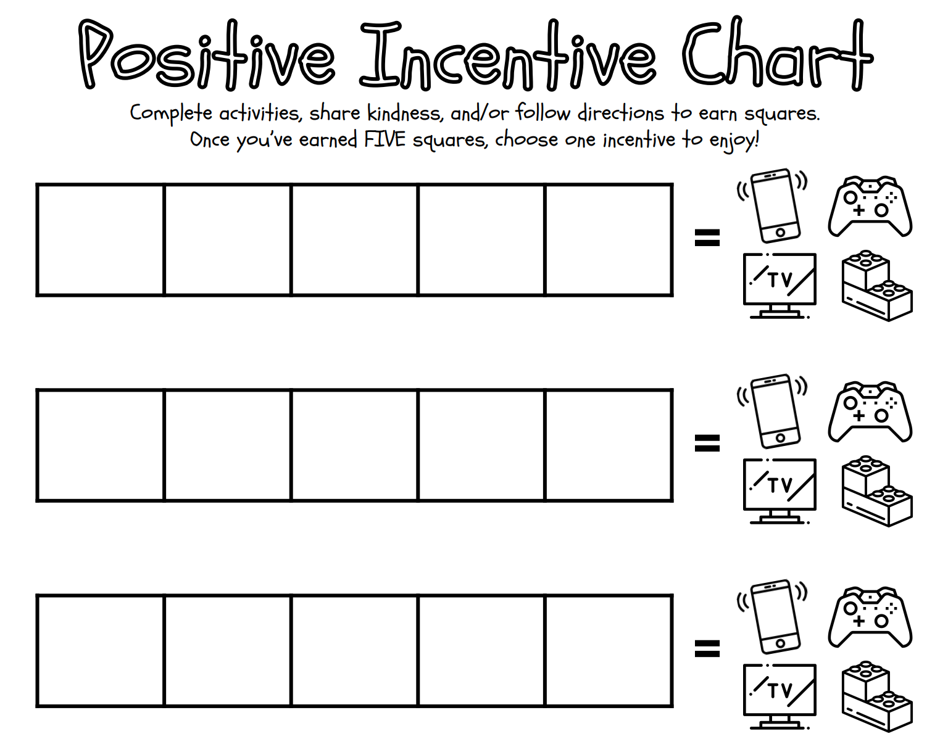

Additional Resource Links for parents and carers of Special Educational Needs pupils
If your child’s struggling to understand what’s happening, here are some helpful resources you can use to support them:
- Childline has advice for children and young people on coronavirus, including tips for coping during lockdown. Young people can also find advice and support on DeafZone and contact a Childline counsellor via sign video.
- Home schooling children with SEND (UCL): a series of information resources to help parents, carers and families support pupils with SEND at home during school closures.
- Kids has resources for parents and carers around coronavirus.
- The National Autistic Society has some helpful resources around coronavirus, and recommends activities to help young people cope with lockdown such as virtual museum tours or movement and mindfulness videos.
- Communication support for families learning at home from the National Deaf Children’s Society (NDCS).
- Tips for children on coping with uncertainty from Autistica.
- Advice on supporting children with challenging behaviour from the Challenging Behaviour Foundation.
- News on coronavirus rules for children with autism and learning disabilities during lockdown.

Booklets
- A wordless booklet from Beyond Words with stories looking at what makes a ‘good day’ or ‘bad day’. It covers social distancing, lockdown, mental health and daily routines.
- Visual leaflet from ACAMH on managing anxiety
- Special needs Jungle has resources and message boards to support families with special needs.

